International Cybersecurity and Digital Forensics Academy (ICDFA)
CIP-B101: Basic Computer Skills for Digital Forensics
LAB 2B PRACTICAL REPORT
Advanced Linux Commands, Standard Streams and Controlled Evidence Transfer
Student Name | Fuseini Imoru Kantuogaa
Course Code | CIP-B101
Course Title | Basic Computer Skills for Digital Forensics
Lab Code | Lab 2B
Lab Title | Advanced Linux Commands, Standard Streams and Controlled Evidence Transfer
Date | June 27–28, 2026
OS (Linux) | Kali Linux (VM) — hostname: kali, IP: 192.168.44.128
OS (Windows) | Windows 10/11 — IP: 192.168.44.1 (VMnet8)

1. Lab Objective
This lab was designed to demonstrate and document practical competence in the following areas:
• Understanding Linux standard streams: stdin (fd 0), stdout (fd 1) and stderr (fd 2), and how these can be redirected for forensic logging purposes.
• Performing safe, authorized file transfer between a Kali Linux VM and a Windows host using netcat/nc without enabling any shell execution.
• Computing and verifying SHA256 and MD5 cryptographic hashes before and after transfer to prove evidence integrity.
• Creating a small test forensic disk image using dd and transferring it across the lab network with hash verification.
• Documenting all actions through command logs, screenshots, and a structured forensic report.

2. Lab Environment

Component | Details
Linux Machine | Kali Linux VM — hostname: kali, IP: 192.168.44.128/24
Windows Machine | Windows 10/11 Host — IP: 192.168.44.1 (VMware VMnet8)
Network | VMware VMnet8 NAT network — subnet 192.168.44.0/24
Linux Tools | bash, echo, cat, ls, ip, ping, nc, sha256sum, md5sum, dd, wget
Windows Tools | Command Prompt, ncat (Nmap), certutil
Evidence Folder | ~/CIP-B101_Lab2B_Fuseini_Imoru on Linux; C:\CIP-B101_Lab2B_Received on Windows

3. Procedure

Part A — Standard Input, Output and Error
Linux treats standard input, output and error as file descriptors. This section demonstrates creating an evidence file and redirecting stdout and stderr into log files for documentation.

Task A1 — Create Lab Folder Structure
The lab directory and all required sub-folders were created using mkdir -p, and the working directory was confirmed with pwd and ls -la.
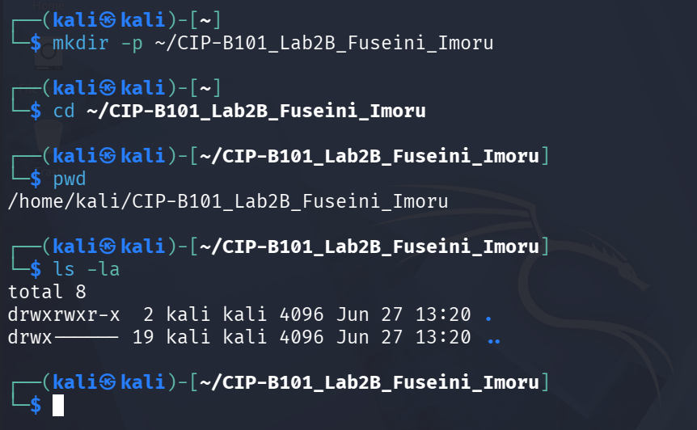
Screenshot A1a — Lab folder ~/CIP-B101_Lab2B_Fuseini_Imoru created and confirmed.

Task A1 — Create Evidence Note File
The evidence note file was created using echo with the > redirect operator and verified with cat and ls -l.
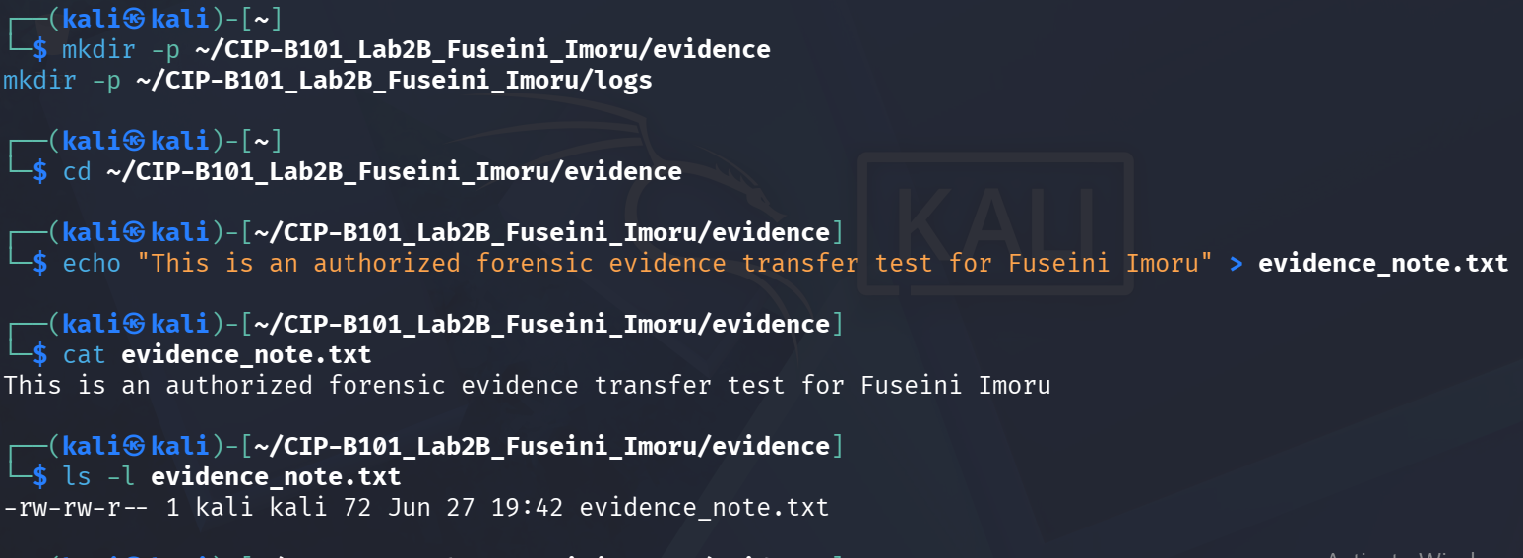
Screenshot A1b — evidence_note.txt created with personalized content, file size confirmed as 72 bytes.

Task A2 — Redirect Standard Output
The ls -la command output was redirected into logs/evidence_listing_stdout.txt using the > operator. This operator captures stdout (file descriptor 1) and writes it to the specified file instead of the terminal. This is valuable in forensic documentation because it creates a permanent, reproducible record of directory state that can be stored as an evidence log.
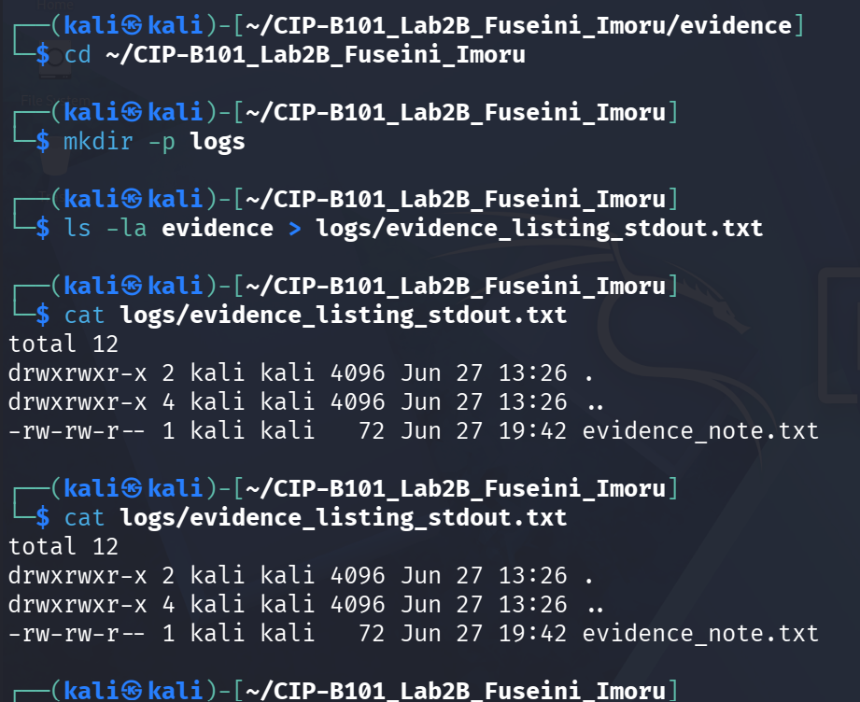
Screenshot A2 — stdout redirected to evidence_listing_stdout.txt; file contents confirmed with cat.

Task A3 — Redirect Standard Error
Attempting to cat a non-existent file generates an error on stderr (fd 2). Using 2> redirected that error message into logs/error_stderr.txt. The terminal displayed nothing, but the error was captured inside the file.

Screenshot A3 — stderr redirected to error_stderr.txt; error message captured: "No such file or directory".

Task A4 — Redirect stdout and stderr Together
The command (ls evidence && cat evidence/file_that_does_not_exist.txt) > logs/combined_output.txt 2>&1 redirects both stdout and stderr to the same file. The 2>&1 syntax means "send file descriptor 2 (stderr) to the same destination as file descriptor 1 (stdout)". The combined_output.txt showed the directory listing followed immediately by the error message, demonstrating that both streams were captured together.
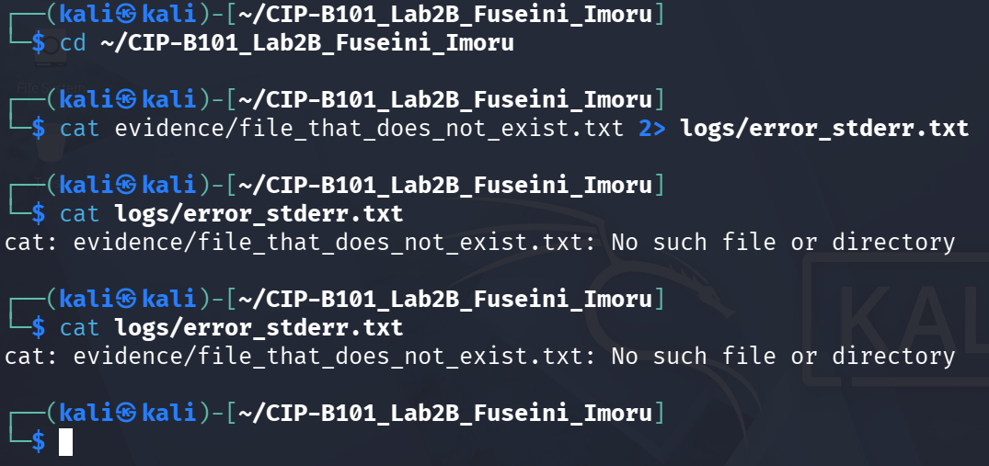
Screenshot A4 — Combined stdout and stderr in combined_output.txt showing ls output and error on one file.

Part B — Baseline System and Network Documentation
Both machines were documented before evidence transfer, mirroring the practice of recording acquisition environment details in a forensic notebook.

Task B1 — Linux Network Details
Hostname, IP address, routing table and netcat availability were all captured and saved to the logs folder using tee.
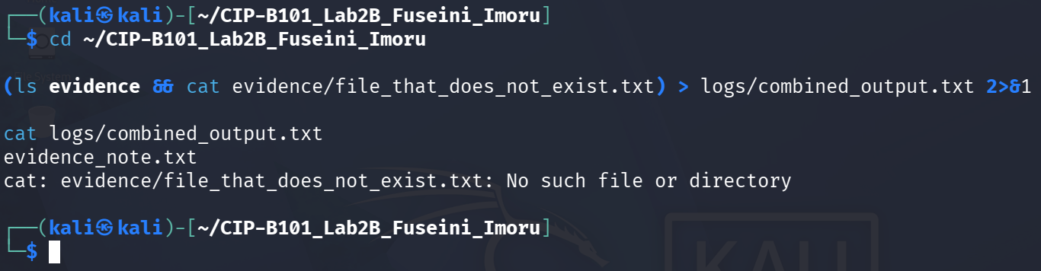
Screenshot B1a — Linux hostname (kali), IP address 192.168.44.128/24, default gateway 192.168.44.2.
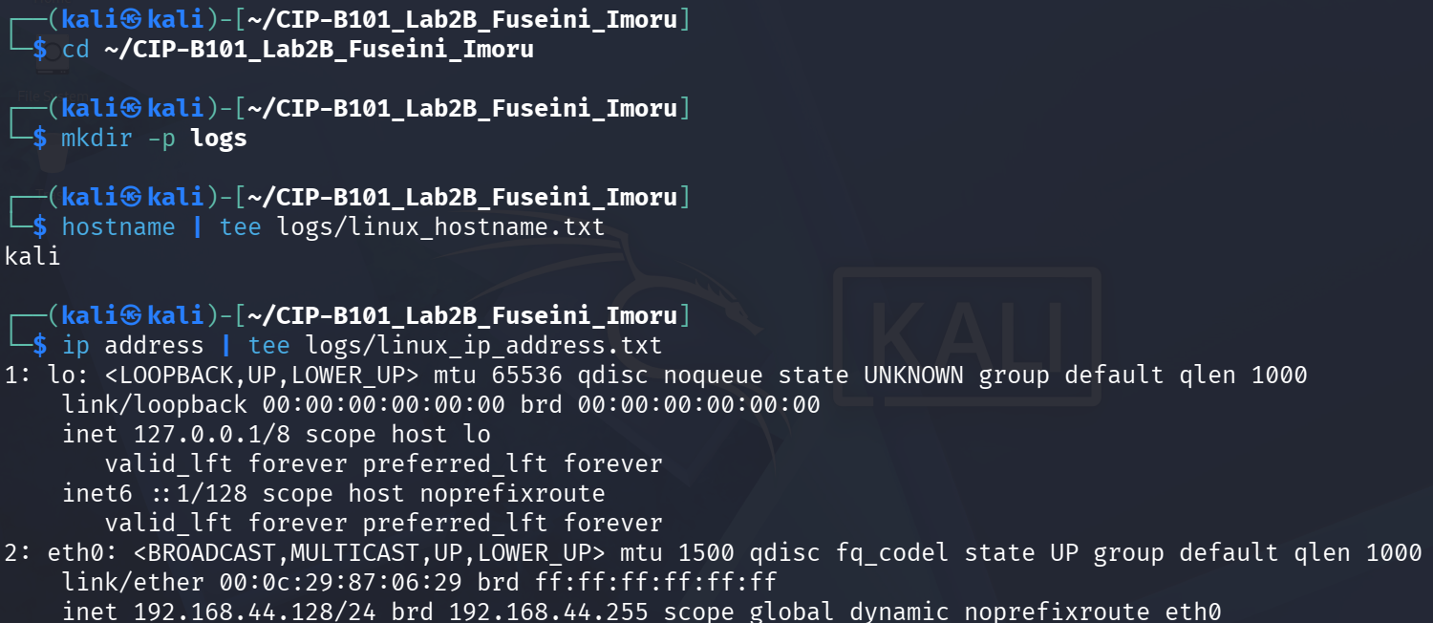
Screenshot B1b — Full ip address output confirming eth0 interface and netcat found at /usr/bin/nc.

Task B2 — Windows Network Details
On Windows, hostname, ipconfig, ncat location and certutil availability were confirmed and logged to C:\Users\user\logs.
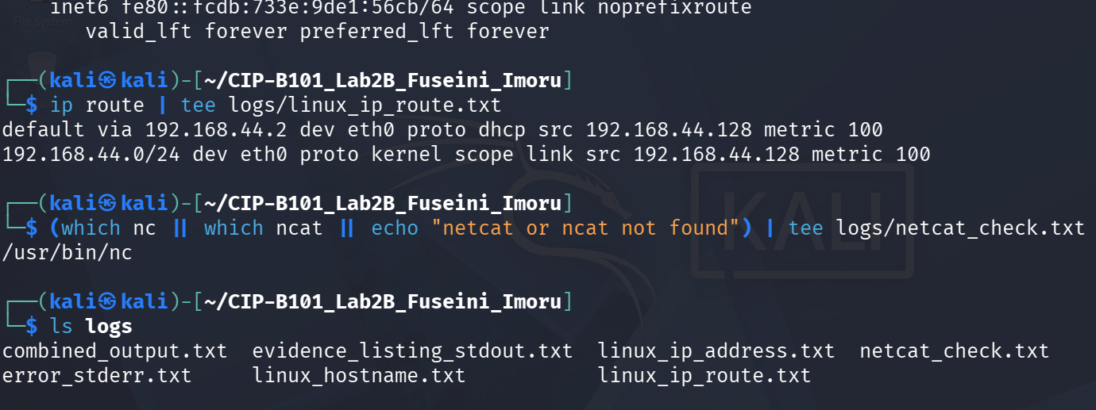
Screenshot B2a — Windows logs folder created; hostname, ipconfig, ncat and certutil outputs saved.
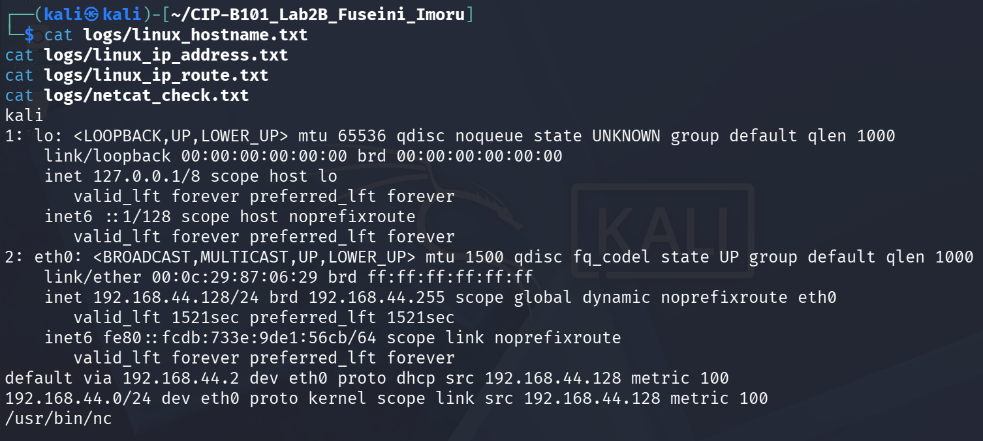
Screenshot B2b — Windows ipconfig showing VMnet8 adapter IP 192.168.44.1 used for file transfer.
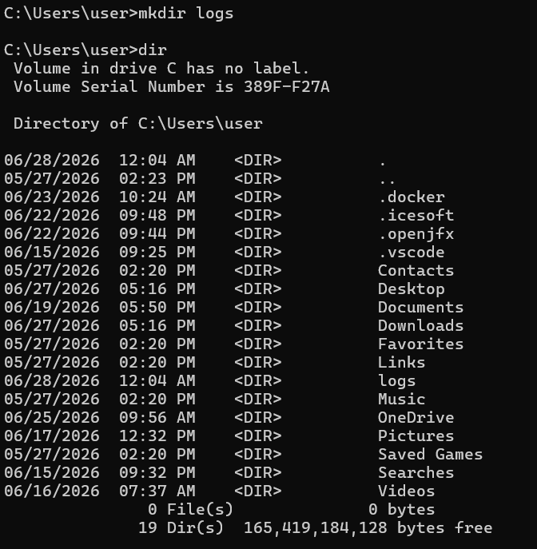
Screenshot B2c — Additional Windows network adapters confirmed (VMnet1: 192.168.48.1, WiFi: 192.168.43.183).

Task B3 — Connectivity Test
A ping from Linux to the Windows machine (192.168.44.1) returned 100% packet loss, indicating that Windows Firewall was blocking ICMP. However, the reverse ping from Windows to the Linux VM (192.168.44.128) was fully successful with 0% loss and sub-1ms response times, confirming that connectivity was functional for file transfer purposes.
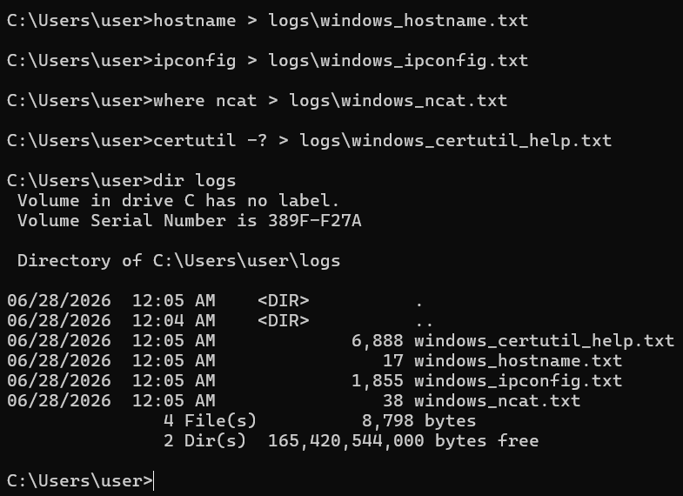
Screenshot B3a — Linux ping to 192.168.44.1 blocked by Windows Firewall (100% loss expected).
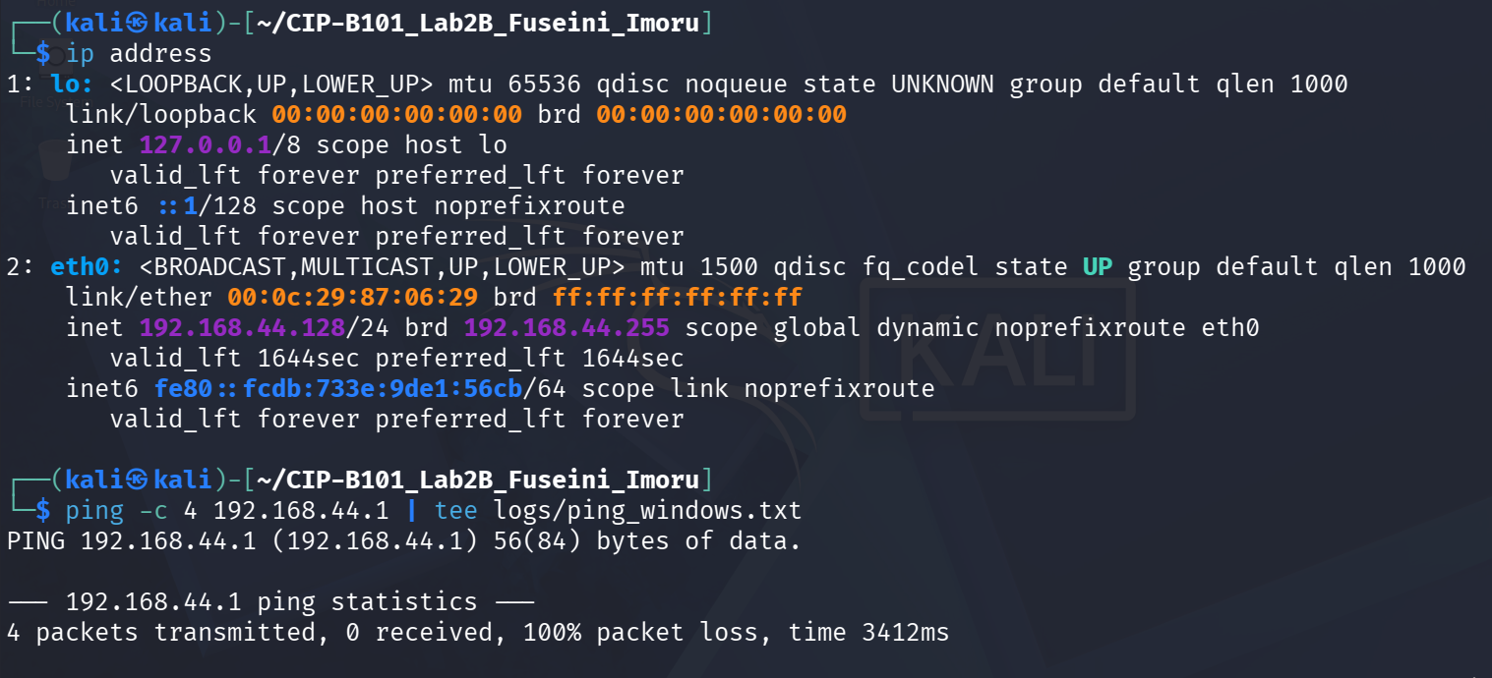
Screenshot B3b — Windows ping to 192.168.44.128 successful: 4/4 packets received, <1ms RTT.

Part C — Hash Evidence Before Transfer
Before transferring any file, cryptographic hashes were computed on the source file to serve as the baseline for integrity verification.
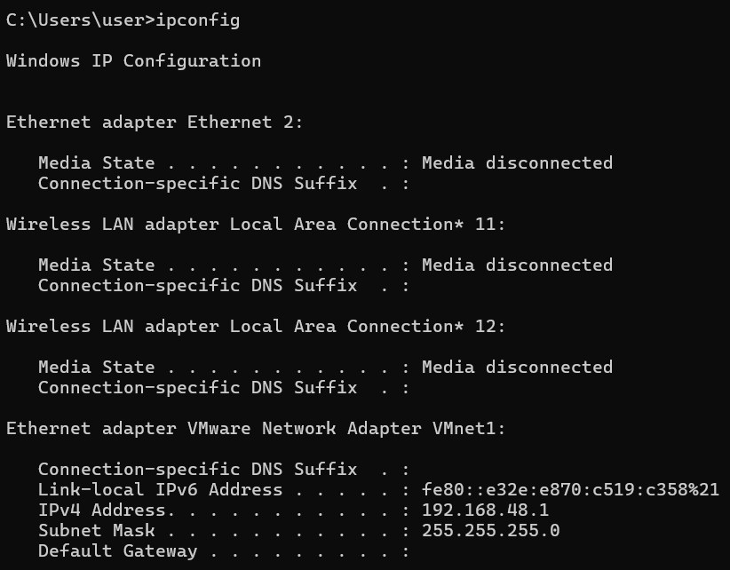
Screenshot C — SHA256 and MD5 hashes computed for evidence_note.txt and saved to the hashes folder.
Source hashes for evidence_note.txt:
File | Algorithm | Hash Value
evidence_note.txt | SHA256 | c2d50f4bc925d2a48df87230f459c53a1a75bbb47557ef5dc2bc6a0b778ca91c
evidence_note.txt | MD5 | 707c887c9f11b05f6b7bb97aa9de7c77

Part D — Linux-to-Windows File Transfer
The evidence_note.txt file was transferred from the Kali Linux VM to the Windows machine using nc (netcat) on port 9090. No shell execution options were used; only data piping was performed.

Task D1 — Start Listener on Windows
On Windows, the command ncat -l -p 9090 > received_evidence_note.txt was run inside C:\CIP-B101_Lab2B_Received to listen for the incoming file.
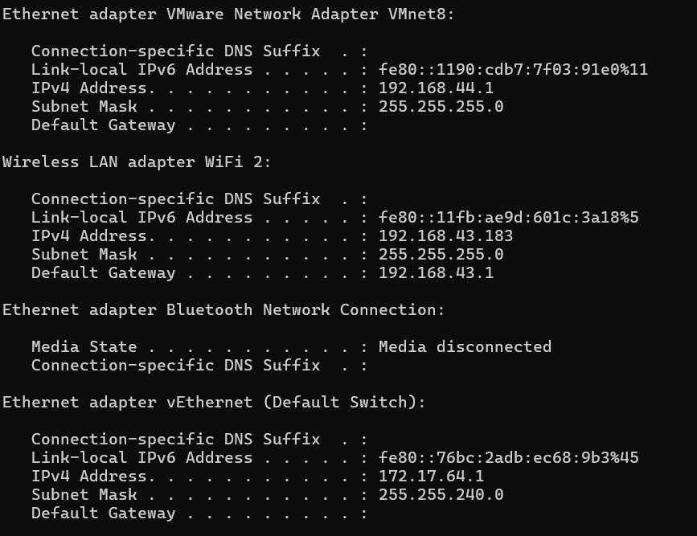
Screenshot D1 — Windows ncat listener started on port 9090; received_evidence_note.txt (72 bytes) confirmed after transfer.

Task D2 — Send File from Linux
The file was sent using nc 192.168.44.1 9090 < evidence_note.txt. The command completed silently, indicating successful transmission.
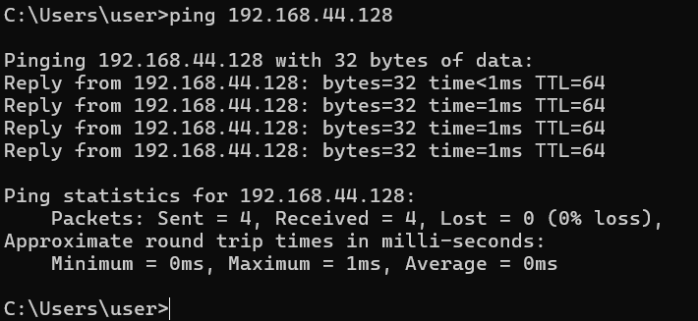
Screenshot D2 — Linux nc command sent evidence_note.txt to Windows listener on 192.168.44.1:9090.

Task D3 — Verify Received File on Windows
The hash of the received file was computed on Windows using certutil. Both SHA256 and MD5 hashes matched the source exactly, proving the file was transferred without any alteration.
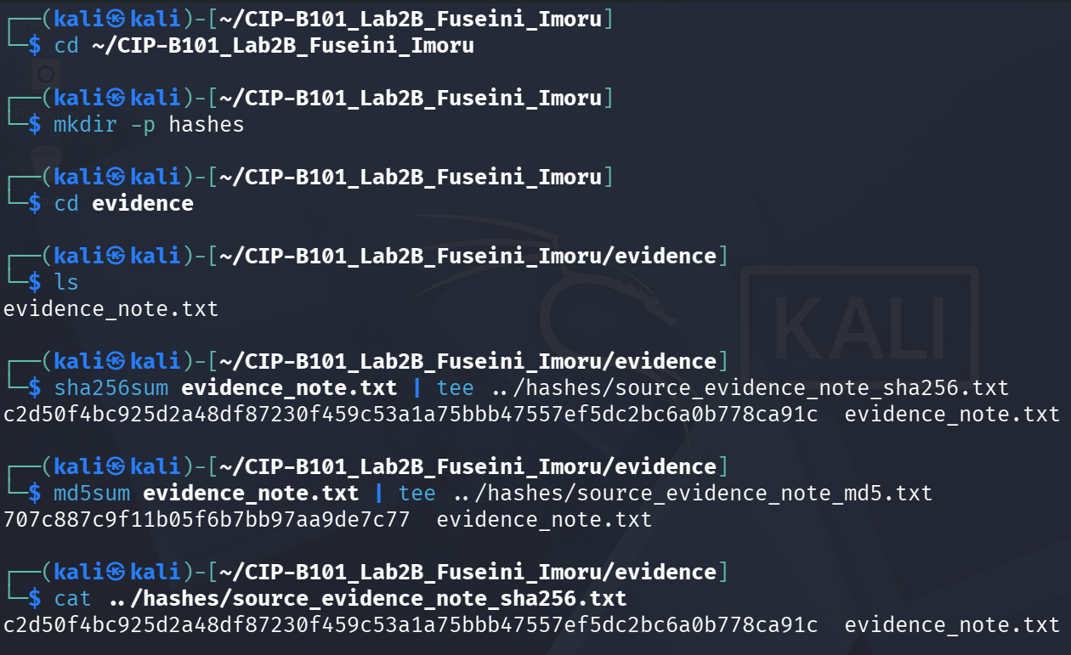
Screenshot D3 — Windows certutil confirmed matching SHA256 and MD5 hashes; file content matches source.
File | Algorithm | Hash Value
received_evidence_note.txt | SHA256 | c2d50f4bc925d2a48df87230f459c53a1a75bbb47557ef5dc2bc6a0b778ca91c
received_evidence_note.txt | MD5 | 707c887c9f11b05f6b7bb97aa9de7c77

Part E — Windows-to-Linux File Transfer
This section reversed the transfer direction. A file was created on Windows and sent to the Linux VM listener.

Task E1 — Create Evidence File on Windows
A file named FuseiniImoruEvidence.txt was created on Windows using echo. Its SHA256 hash was computed with certutil before transfer.
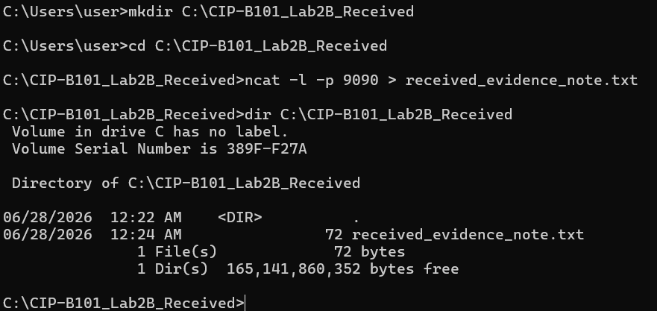
Screenshot E1 — FuseiniImoruEvidence.txt created on Windows; SHA256 hash computed before transfer.

Task E2 — Start Listener on Linux
On Linux, nc -l -p 9091 > FuseiniImoruEvidence_received.txt was run in the received folder to wait for the incoming Windows file.
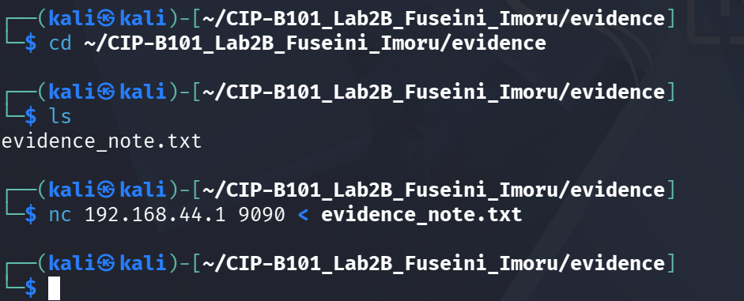
Screenshot E2 — Linux nc listener started on port 9091; file confirmed in received folder after transfer.

Task E3 — Send from Windows
The file was sent from Windows using ncat 192.168.44.128 9091 < FuseiniImoruEvidence.txt.
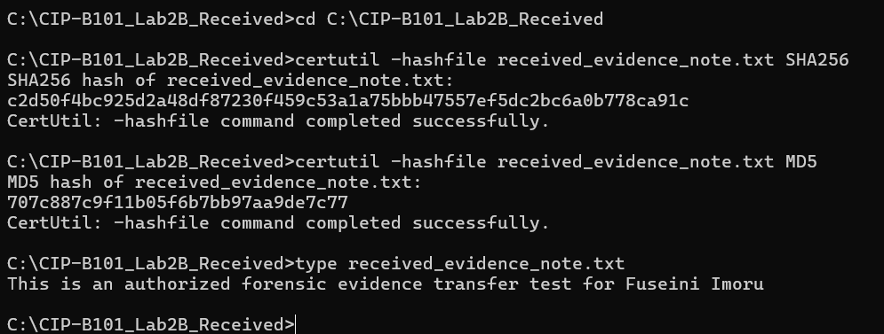
Screenshot E3 — Windows ncat sent FuseiniImoruEvidence.txt to Linux listener on 192.168.44.128:9091.

Task E4 — Verify on Linux
The received file was verified by displaying its content and computing its SHA256 hash. The hash matched the Windows source hash exactly.
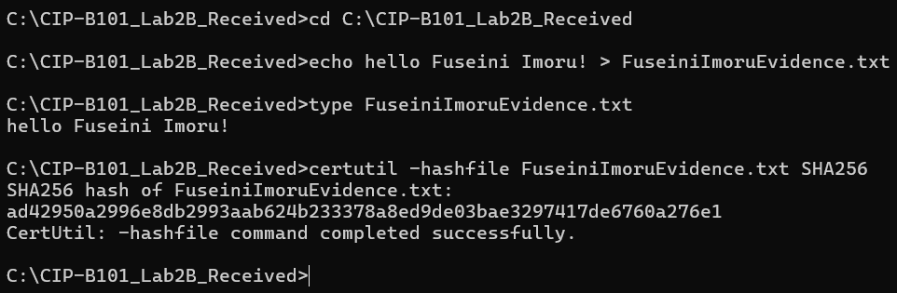
Screenshot E4a — Received file content: "hello Fuseini Imoru!" confirmed on Linux.
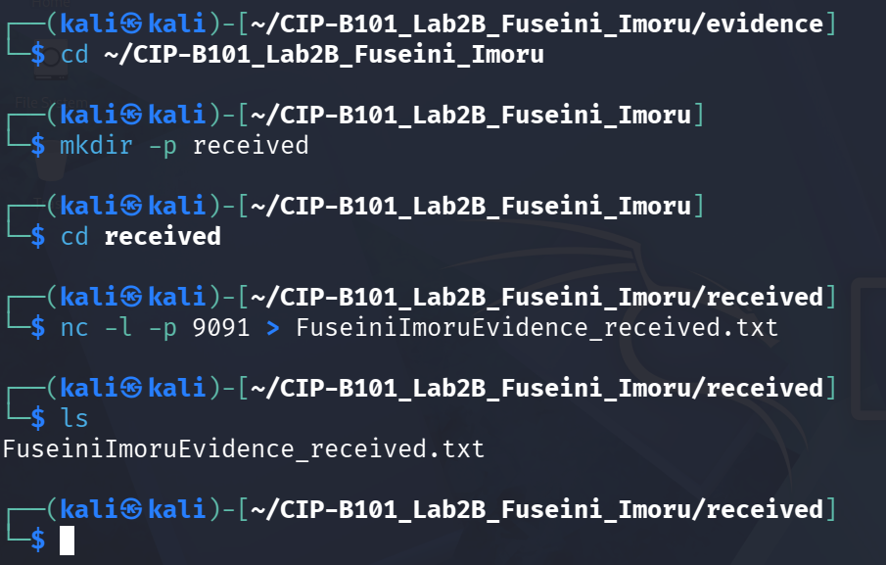
Screenshot E4b — SHA256 hash of received file matches Windows source hash; hashes folder listing confirmed.
Screenshot E4c — Hash file content confirmed: ad42950a2996e8db2993aab624b233378a8ed9de03bae3297417de6760a276e1.
File | Algorithm | Hash Value
FuseiniImoruEvidence.txt (Windows source) | SHA256 | ad42950a2996e8db2993aab624b23337  8a8ed9de03bae3297417de6760a276e1
FuseiniImoruEvidence_received.txt (Linux) | SHA256 | ad42950a2996e8db2993aab624b23337  8a8ed9de03bae3297417de6760a276e1

Part F — Small Test Evidence Image Transfer Using dd
A 5 MB test evidence image was created using dd from /dev/zero with a custom ICDFA marker written at offset 1024. The image was hashed, transferred to Windows and verified.

Task F1 — Create Test Evidence Image
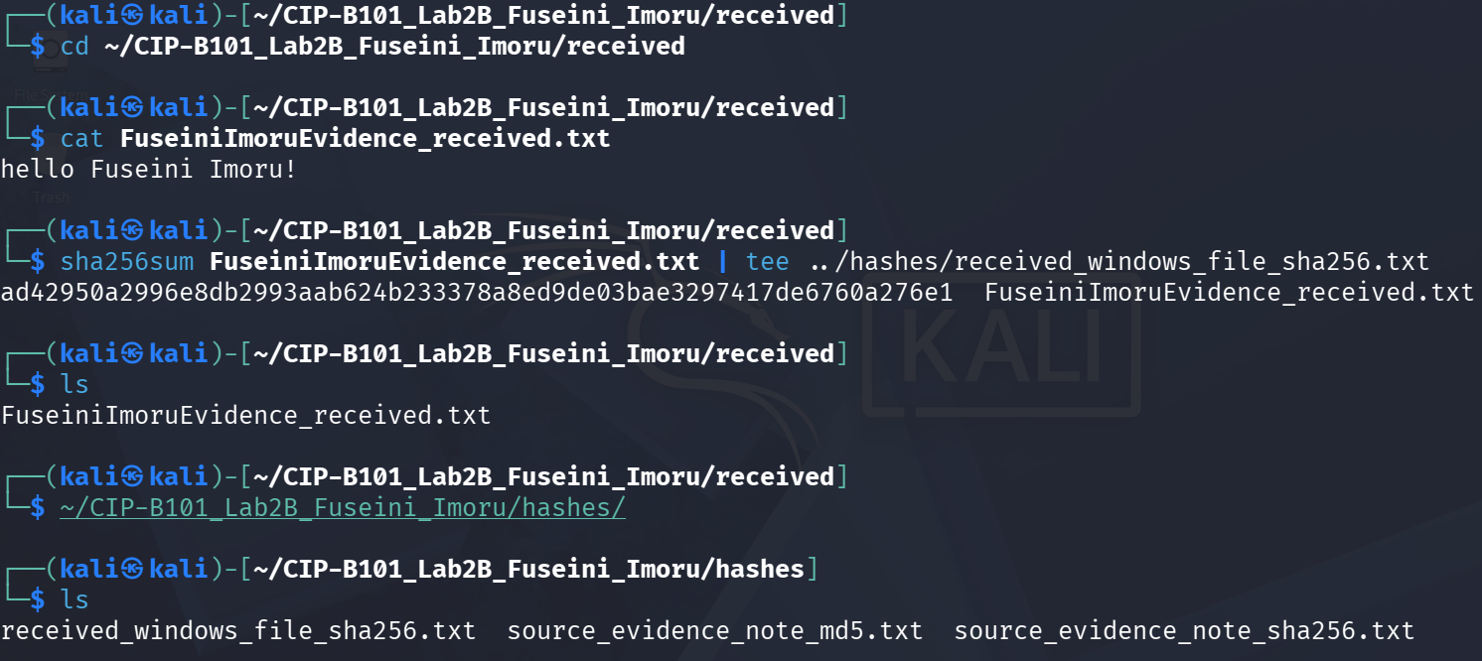
Screenshot F1 — 5 MB test_evidence_image.dd created with dd; ICDFA marker written; SHA256 hash computed.
File | Algorithm | Hash Value
test_evidence_image.dd (source) | SHA256 | bcc42d394180b1153e6423e0607adeba4bdbe07e61f320abf543ab7ed75f47be

Task F2 — Transfer Image to Windows
Windows listener ncat -l -p 9092 > test_evidence_image_received.dd was started, then Linux sent the image using nc 192.168.44.1 9092 < test_evidence_image.dd.
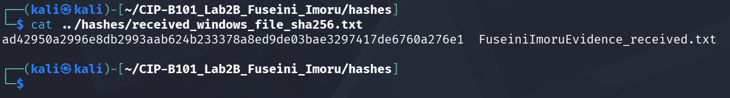
Screenshot F2a — Windows ncat listener on port 9092 received test image; file size confirmed as 5,242,880 bytes.
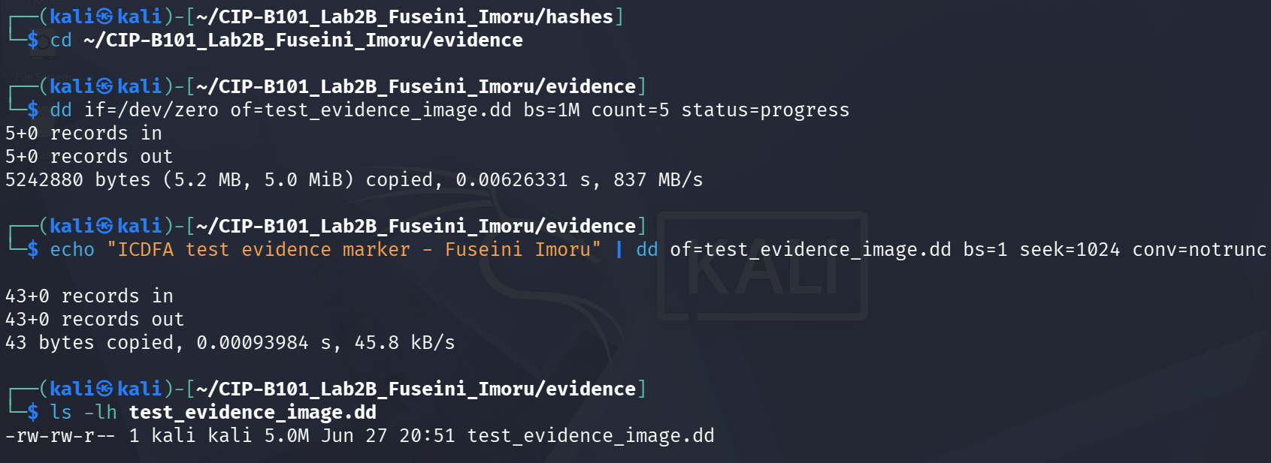
Screenshot F2b — Linux nc sent test_evidence_image.dd to Windows; transfer completed silently.

Task F3 — Verify Image Hash on Windows
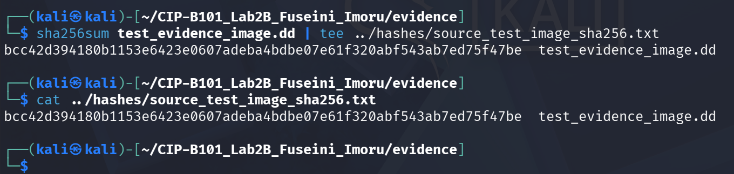
Screenshot F3 — Windows certutil SHA256 hash of received .dd image matches source hash exactly.
File | Algorithm | Hash Value
test_evidence_image_received.dd (Windows) | SHA256 | bcc42d394180b1153e6423e0607adeba4b  dbe07e61f320abf543ab7ed75f47be
test_evidence_image.dd (Linux source) | SHA256 | bcc42d394180b1153e6423e0607adeba4bd  be07e61f320abf543ab7ed75f47be

Part G — Optional dd Block Size Test (Completed)
The dd_obs_test.sh script was downloaded from GitHub, made executable and run against the Linux machine. Results were saved to dd_block_size_test_result.txt.
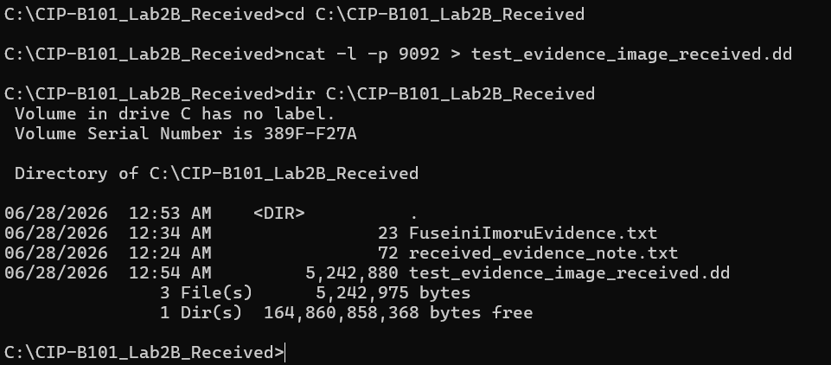
Screenshot G1 — Script downloaded from raw.githubusercontent.com and made executable.
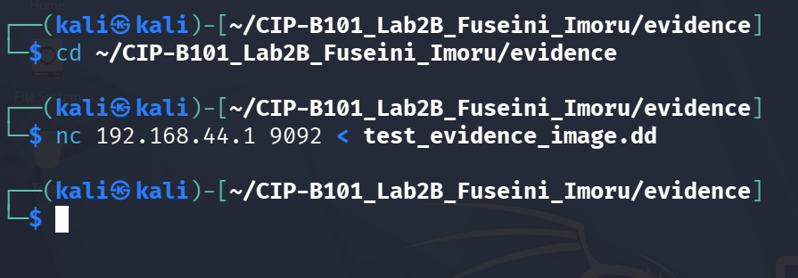
Screenshot G2 — dd block size test results: peak performance at 8388608 bytes (1.7 GB/s).
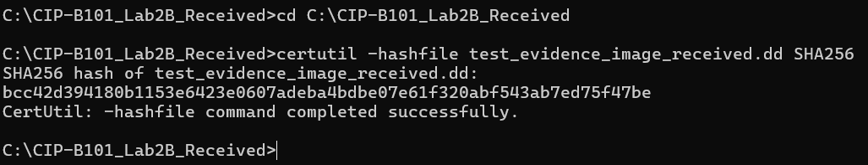
Screenshot G3 — Full block size test results confirmed in dd_block_size_test_result.txt.

4. Evidence Integrity Summary
All file transfers produced hashes that matched the source exactly. The table below summarises the complete integrity chain for all transferred files.
File | Algorithm | Hash Value
evidence_note.txt → Windows | SHA256 | c2d50f4bc925d2a48df87230f459c53a1a75bbb47557ef5dc2bc6a0b778ca91c ✓ MATCH
evidence_note.txt → Windows | MD5 | 707c887c9f11b05f6b7bb97aa9de7c77 ✓ MATCH
FuseiniImoruEvidence.txt → Linux | SHA256 | ad42950a2996e8db2993aab624b233378a8ed9de03bae3297417de6760a276e1 ✓ MATCH
test_evidence_image.dd → Windows | SHA256 | bcc42d394180b1153e6423e0607adeba4bdbe07e61f320abf543ab7ed75f47be ✓ MATCH
A matching hash before and after transfer proves that no bits were altered during transmission. This is a fundamental requirement in digital forensics to establish admissibility and chain of custody.

5. Reflection Answers (Part H)

Q1: What is the difference between standard output and standard error?
Standard output (stdout, fd 1) carries normal command results for example the output of ls or cat on an existing file. Standard error (stderr, fd 2) carries error and diagnostic messages for example the "No such file or directory" message when a file does not exist. Both normally appear on the terminal, but they can be redirected independently. In forensics this allows a practitioner to capture clean command output in one log file and all errors in a separate log, making investigation records easier to review and audit.

Q2: Why is command redirection useful during digital forensic documentation?
Redirection turns transient terminal output into permanent files that form part of the evidence record. Every command a forensic examiner runs can be logged automatically rather than manually transcribed. This reduces human error, creates a timestamped audit trail, and means that any reviewer can verify exactly what commands were run and what results were produced without having to rely on memory or handwritten notes.

Q3: Why must a forensic examiner calculate the hash of a file before and after transfer?
A hash function produces a fixed-length fingerprint that is statistically unique to the data it represents. Even a single changed bit produces a completely different hash. By computing the hash before transfer and then computing it again on the received file, the examiner can prove beyond reasonable doubt that the evidence file is identical to the original and was not corrupted, modified, or tampered with during transmission or storage. This is a legal and procedural requirement in most digital forensic frameworks.

Q4: Why is it unsafe and unethical to use remote shell access on a system without authorization?
Unauthorized remote shell access is an intrusion. It violates computer misuse laws in virtually every jurisdiction, potentially invalidates any evidence collected because the examination method itself becomes legally contestable, and may cause unintended changes to the target system that destroy evidence or disrupt operations. A forensic examiner must have explicit written authorization from the system owner or a court order before performing any acquisition. Unauthorized access also exposes the examiner to criminal prosecution.

Q5: What is the difference between a bind shell and a reverse shell?
A bind shell is a process on the target machine that opens a listening port and waits for an incoming connection from the attacker. When the attacker connects, they receive a shell on the target. A reverse shell works in the opposite direction the target machine initiates an outbound connection back to a listener on the attacker’s machine. Reverse shells are frequently used by attackers because outbound connections are often permitted through firewalls whereas inbound connections to arbitrary ports may be blocked. Understanding both concepts is important for forensic examiners who must recognize attacker behaviour in network logs and memory artifacts.

Q6: Why might a firewall block one type of connection but allow another?
Firewalls typically apply different rules to inbound and outbound traffic. Many enterprise and personal firewalls allow all outbound connections by default but block unexpected inbound connections. This means a bind shell (which requires an inbound connection to the target) may be blocked, while a reverse shell (which makes an outbound connection from the target to the attacker) may pass through undetected. Firewalls can also filter by port, protocol, or application. Understanding these asymmetric rules is essential both for attackers who exploit them and for defenders and forensic examiners who must detect and investigate the resulting connections.

Q7: Why did this lab use a small test evidence image instead of imaging a real disk?
Imaging a real system disk without authorization is illegal and unethical. Even imaging one’s own disk in a lab environment without careful controls risks overwriting evidence, consuming large amounts of storage, or causing accidental data loss. The 5 MB dd test image produced exactly the same learning outcomes image creation with dd, hash computation, network transfer, and hash verification without any of these risks. In a real forensic engagement, the examiner would image an authorized acquisition target using write-blocked hardware and would document every step of the process.

6. Findings
1. All three file transfers (Linux→Windows text file, Windows→Linux text file, Linux→Windows .dd image) completed successfully with 100% hash integrity confirmed.
2. The > and 2>&1 redirection operators successfully captured command output and error messages into evidence log files.
3. The Linux machine IP (192.168.44.128) and Windows VMnet8 IP (192.168.44.1) were on the same /24 subnet, enabling direct netcat communication.
4. ICMP (ping) from Linux to Windows was blocked by Windows Firewall, which is the expected default behaviour. TCP on port 9090–9092 was permitted because the ncat listener explicitly opened those ports.
5. The dd block size test demonstrated that block sizes between 32768 and 131072 bytes consistently achieved the highest throughput (~1.5 GB/s), with a secondary peak at 8388608 bytes (1.7 GB/s).
6. The tee command proved useful throughout the lab because it simultaneously displayed output on the terminal and wrote it to a log file, avoiding the need to run commands twice.

7. Conclusion
This lab provided practical experience with three core Linux forensic skills: stream redirection for evidence logging, cryptographic hash verification for evidence integrity, and controlled file transfer using netcat. Every file transferred in this lab arrived with a hash that was byte-for-byte identical to the source, demonstrating that netcat provides a reliable, forensically sound transfer mechanism when used correctly and without shell execution options.
The theoretical section reinforced why authorization is not optional in digital forensics: unauthorized shell access compromises the legality of any evidence collected and exposes the examiner to criminal liability. The use of a small test image rather than a real disk image reflects the same principled approach doing only what is necessary and authorized.
The skills practised here stream control, hash chaining and network acquisition are directly applicable to real-world forensic acquisitions, incident response, and evidence handling under chain-of-custody requirements.

8. Evidence Packaging
The complete lab folder was compressed using tar -czvf on the Linux VM into a single archive for submission. The final archive CIP-B101_Lab2B_Fuseini_Imoru_Evidence.tar.gz contained all logs, hashes, evidence files and the received directory.
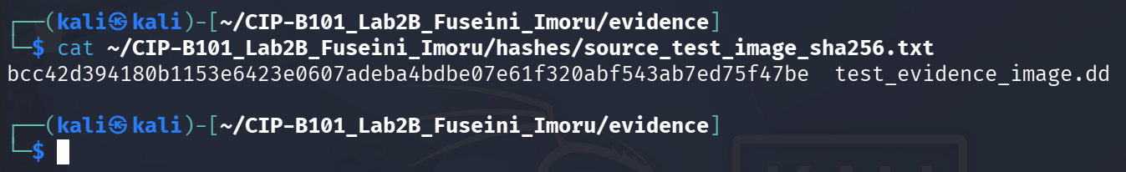
Screenshot — tar archive listing showing all evidence sub-folders included in the compressed package.
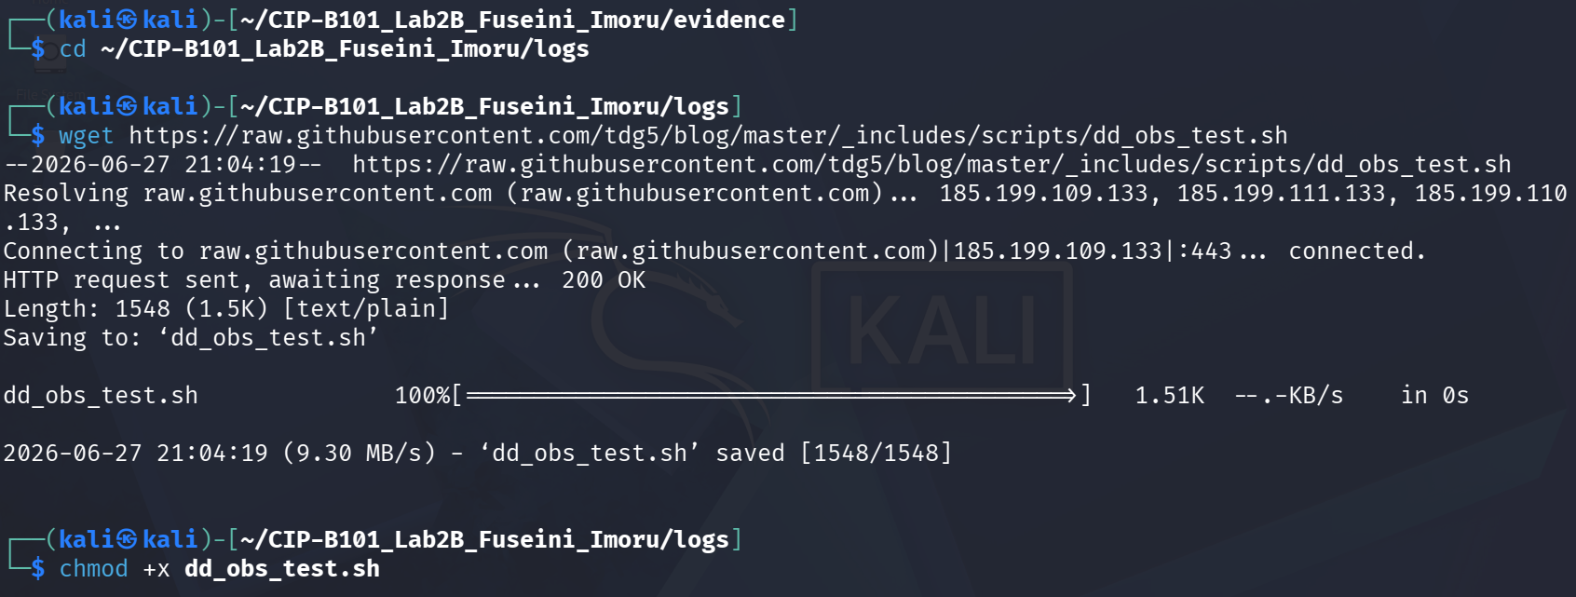
Screenshot — Continued tar listing showing hashes, logs, received and evidence contents.
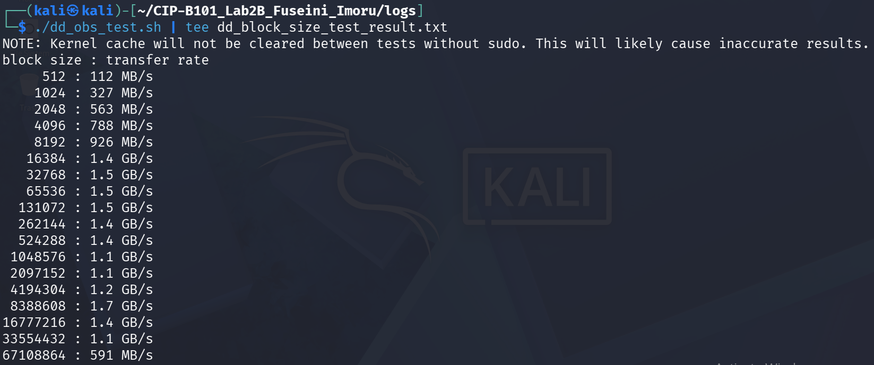
Screenshot — Further tar listing showing all log files captured during the lab.
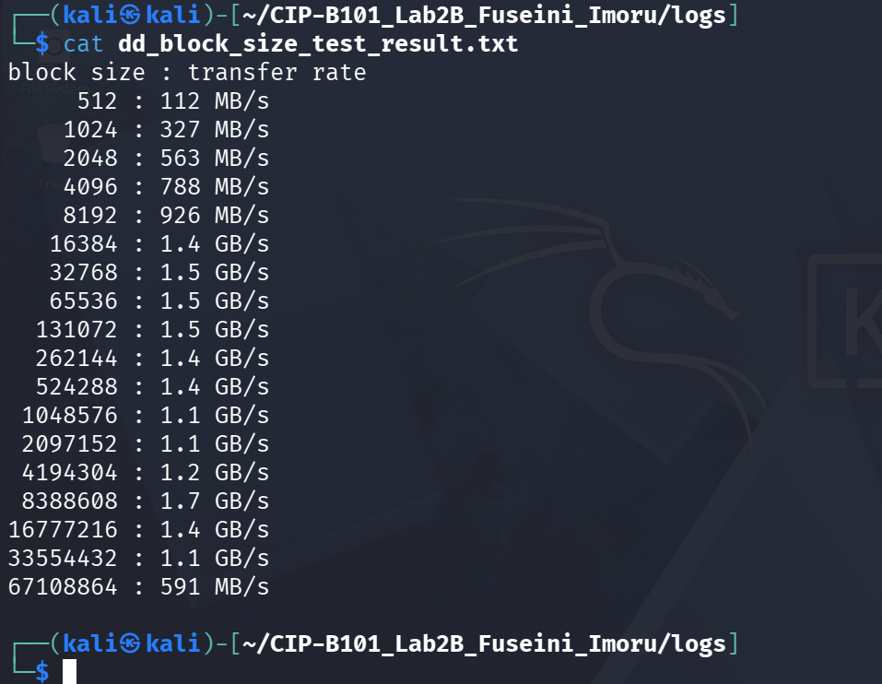
Screenshot — Evidence folder contents confirmed inside the archive.
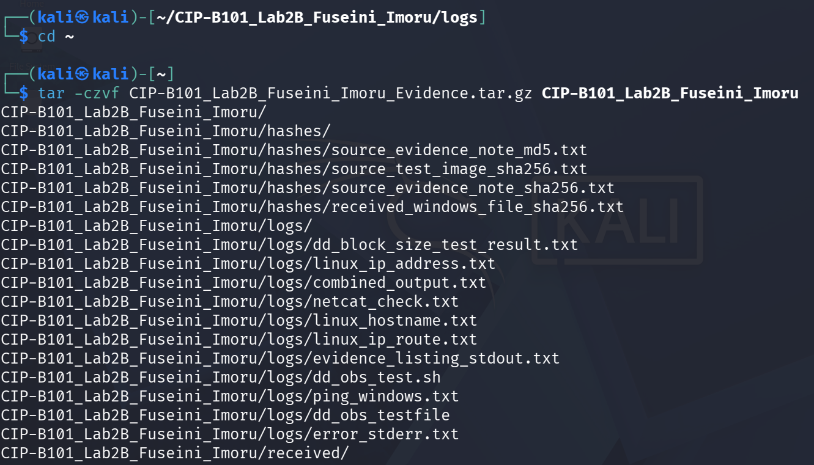
Screenshot — Final archive file size: 136K — CIP-B101_Lab2B_Fuseini_Imoru_Evidence.tar.gz created successfully.
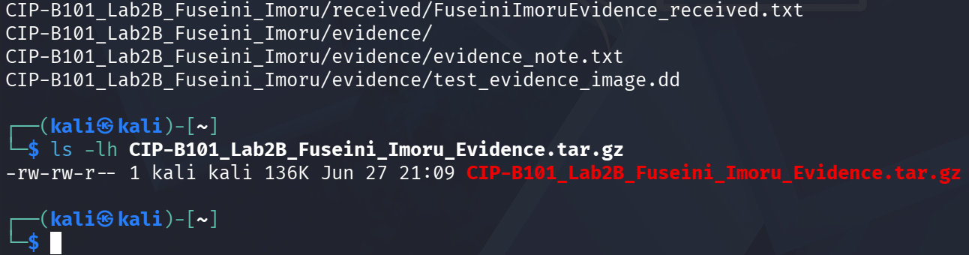
Screenshot — Compressed archive confirmed: 136K, created Jun 27 21:09.

